Final Project Report

Image Analysis For
Automated Defect Detection



Project Supervisor

Dr. Shabib Aftab

Submitted By

Bc22041622

Saba Gulam Rasool Bc22041622

Software Projects & Research Section,
Department of Computer Sciences,
Virtual University of Pakistan


CERTIFICATE

This is to certify that Saba Gulam Rasool (Bc22041622), have worked on and completed their Software Project at Software & Research Projects Section, Department of Computer Sciences, Virtual University of Pakistan in partial fulfillment of the requirement for the degree of BS in Computer Sciences under my guidance and supervision.

In our opinion, it is satisfactory and up to the mark and therefore fulfills the requirements of BS in Computer Sciences.

Supervisor / Internal Examiner

Dr. Shabib Aftab
Supervisor,
Software Projects & Research Section,
Department of Computer Sciences
Virtual University of Pakistan

___________________
(Signature)

External Examiner/Subject Specialist
<<External Supervisor Name>>

___________________
(Signature)

Accepted By:

_____________
(For office use)

EXORDIUM

In the name of Allah, the Compassionate, the Merciful.

Praise be to Allah, Lord of Creation,
The Compassionate, the Merciful,
King of Judgment-day!

You alone we worship, and to You alone we pray for help,
Guide us to the straight path

The path of those who You have favored,

Not of those who have incurred Your wrath,
Nor of those who have gone astray.

DEDICATION

بِسْمِ ٱللّٰهِ ٱلرَّحْمٰنِ ٱلرَّحِيمِ

IN THE NAME OF ALLAH WHO IS MOST BENIFICIENT AND THE MOST MERCIFUL

I dedicate this project to my loving

Mother and Teachers

And

To the loving memories of my Father

And also

To my brothers and sister

Your support made me the person I am becoming

You will always be remembered.
ACKNOWLEDGEMENT

I would like to express my sincere gratitude to Almighty Allah for giving me the strength, knowledge, and determination to complete this project.

I am deeply thankful to my supervisor, Dr. Shabib Aftab, for his continuous guidance, encouragement, and constructive feedback, which greatly contributed to the successful completion of this work.

My appreciation also goes to the Virtual University of Pakistan for providing a supportive learning environment, quality education, and the resources needed to pursue this project effectively.

Finally, I extend heartfelt thanks to my family and friends for their constant motivation, patience, and support throughout this journey.

PREFACE

This project, titled “Image Analysis for Automated Defect Detection,” has been completed as part of the requirements for the BS (Computer Science) program at the Virtual University of Pakistan.

The objective of this work is to design and implement a functional prototype capable of detecting visible surface defects using classical image processing techniques.

The prototype includes key features such as user registration and login, image upload functionality, and a basic defect detection module. Using Python and OpenCV, the system performs preprocessing steps—including grayscale conversion, noise reduction, and edge detection—to identify and highlight potential defect regions.

This phase forms the foundation for advanced enhancements that will be incorporated in the final version of the project.

I am sincerely grateful to my supervisor, Dr. Shabib Aftab, for his guidance and support throughout this work. I would also like to extend my thanks to the Virtual University of Pakistan for providing quality education and continuous academic support.
This project is submitted by Saba Gulam Rasool, (Bc220416292), 7th Semester, Virtual University of Pakistan.

TABLE OF CONTENTS

CHAPTER NO. 1
gathering & Analyzing info 10

1.1 Introduction

1.2 purpose

1.3 scope

1.4 definitions, acronyms and abbreviations

1.5 Project requirements

1.5.1 Functional Requirements

1.5.2 Non-Functional Requirements

1.6 use cases and usage scenarios

1.6.1 Use Case Diagrams

1.6.2 Usage Scenarios

1.7 Development Methodology

1.7.1 Chosen Methodology

1.7.2 Reasons for Chosen Methodology
1.7.2 Work Plan (Gantt Chart)
1.7.2 Project Schedule (Submission Calendar)

CHAPTER NO. 2
designing the project 12

2.1 Introduction

2.2 purpose

2.3 scope

2.4 definitions, acronyms and abbreviations

2.5 Architectural Representation (Architecture Diagram)

2.6 Dynamic Model: Sequence Diagrams

2.7 Object Model/Logical Model: Class Diagram

2.8 Database Model (Database Diagram)

2.9 Graphical User Interfaces

Chapter no.3
DEvelopment 13
3.1 Development plan (Architecture Diagram)

CHAPTER 1
Gathering & Analyzing Info

Introduction

In many industrial sectors such as oil and gas, construction, and manufacturing, early detection of surface defects is critical for ensuring safety, reducing maintenance costs, and preventing equipment failure. Traditional inspection methods rely heavily on manual observation, which is time-consuming, subjective, and prone to human error. This project presents an automated defect detection system that uses image processing techniques to identify cracks, dents, and other visible imperfections from uploaded images. By combining preprocessing, edge detection, and contour-based analysis within a user-friendly web interface, the system provides a fast, consistent, and efficient approach to evaluating structural conditions.

Purpose of the Project
The purpose of this project is to develop an automated system that can accurately detect visible surface defects using image processing techniques. Industrial inspections often depend on manual checking, which is slow, inconsistent, and easily influenced by human error. This project aims to provide a faster and more reliable alternative by allowing users to upload images and automatically receive defect-highlighted results. By improving the speed and consistency of inspections, the system supports safer decision-making and reduces the effort required during routine maintenance and quality-control processes.

1.3 Scope
The scope of this project covers the design and development of a prototype system that automatically detects visible defects from digital images. The system allows users to register, log in, upload images, and receive processed outputs where cracks, dents, and similar surface abnormalities are highlighted. The prototype focuses on classical image-processing techniques such as grayscale conversion, noise reduction, edge detection, and contour marking. The project also includes a simple reporting feature that summarizes the detected defects. Advanced features like admin management, database integration, or deep-learning detection models are considered outside the scope of the prototype and can be included as future enhancements.

1.4 Definitions, Acronyms and Abbreviations
This section provides the key terms and abbreviations used throughout the project documentation to ensure clarity and consistent understanding.
- Defect – Any visible surface irregularity such as a crack, dent, scratch, or deformation that appears on industrial equipment or infrastructure.
- Image Processing – A method of applying computational techniques to analyze and transform digital images for meaningful insights.
- Preprocessing – Initial steps applied to an image (such as resizing, grayscale conversion, and noise removal) to improve detection accuracy.
- Edge Detection – A technique used to identify sudden changes in brightness, helping highlight boundaries of defects.
- Contour Detection – A process used to locate and outline shapes or irregular patterns in an image.
- ROI (Region of Interest) – The specific area of an image that contains meaningful features, often marked or highlighted after processing.
- UI (User Interface) – The visual part of the system that users interact with, including buttons, forms, and uploaded results.
- UX (User Experience) – The overall usability and satisfaction that users feel when interacting with the system.
- Prototype – The initial working version of the system that includes core features and demonstrates main functionalities.
- Algorithm – A step-by-step computational method used to process an image and detect defects.
- OpenCV – An open-source computer vision library widely used for image analysis and machine-learning tasks.
- Flask – A lightweight Python web framework used to build the user interface and back-end logic of the system.

1.5 Project Requirements
This section outlines the essential requirements that the system must fulfill to meet the objectives of the automated defect detection project. The requirements are divided into functional and non-functional categories to provide a clear understanding of what the system must do and how it should behave.

1.5.1 Functional Requirements
The functional requirements define the specific actions and features that the system must support:
- User Registration and Login
The system must allow users to create an account, log in securely, and access the application.
- Image Upload
Users must be able to upload digital images (e.g., JPG, PNG) for defect analysis.
- Image Preprocessing
The system must preprocess the uploaded image by performing tasks such as resizing, grayscale conversion, and noise reduction to prepare it for analysis.
- Defect Detection
The application must analyze the preprocessed image using classical image-processing techniques, including edge detection and contour extraction, to identify cracks, dents, or other surface irregularities.
- Result Visualization
The system must display both the original and processed images to the user, with clearly highlighted defect regions.
- Defect Summary Report
The system must generate a simple summary that includes the number of detected defects and the processed image with visual markings.
- Logout Functionality
Users must be able to securely log out of the system after completing their tasks.

1.5.2 Non-Functional Requirements
Non-functional requirements describe the quality attributes, performance expectations, and constraints of the system:
- Usability
The interface should be simple, intuitive, and easy to navigate for users with minimal technical background.
- Performance
The system should process and display results within a reasonable time so that users do not experience noticeable delays.
- Reliability
The defect detection process should deliver consistent output for similar images under similar conditions.
- Scalability
The prototype should be designed in a way that allows future expansion, such as integrating a database, admin panel, or deep-learning-based detectors.
- Security
User credentials and uploaded images should be handled securely, ensuring no unauthorized access.
- Maintainability
The code should be structured and documented clearly to allow future upgrades or modifications without difficulty.
- Compatibility
The system should run smoothly on modern web browsers and support standard image formats.

1.6 Use Cases and Usage Scenarios
This section describes how different actors interact with the system and outlines the key activities involved in the defect detection process. Use cases help define the system’s functional behavior from the user’s perspective, while usage scenarios explain how these interactions occur step by step.

1.6.1 Use Case Diagrams
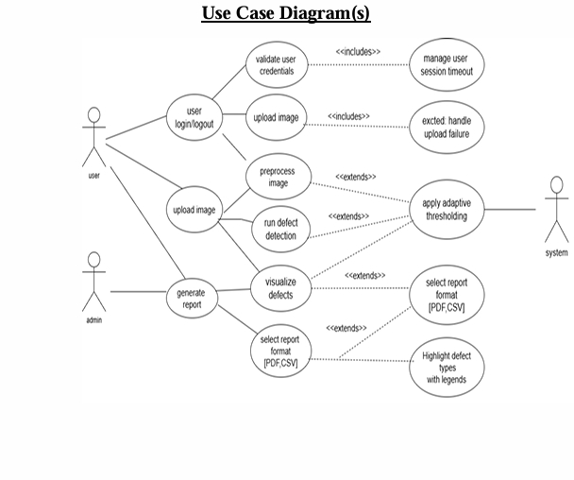

1.6.2 Usage Scenarios

UC01a: Validate User Credentials:
User Case ID | UC01a
User Case title | Validate User Credentials
Actor | System
Description | Checks user credentials entered during  login against stored records.
Precondition | User initiates login with username and  password.
Postcondition | System either authenticates the user or  rejects access.
- Main Flow:
  - User enters login credentials.
  - System verifies credentials in database.
  - Access granted if credentials are correct.

- Alternate Flow:
  - If credentials invalid, forward to 'Handle Invalid Login Attempts.

UC01b: Handle Invalid Login Attempts:
User Case ID | UC01b
User Case Title | Handle Invalid Login Attempts
Actor | System
Description | Logs and restricts access after multiple  failed login attempts.
Precondition | Login attempts with incorrect credentials.
Postcondition | Error shown or account locked after  multiple failures.
- Main Flow:
  - System detects incorrect credentials.
  - Failure counter is incremented.
  - Show error message to user.

- Alternate Flow:
  - Lock account after 3 failed attempts.

UC00: Manage User Session Timeout
User Case ID | UC00

User Case Title | Manage User Session Timeout
Actor | System
Description | Ends inactive user sessions after a set timeout.
Precondition | User is logged into the system.
Postcondition | User session ends automatically after timeout.

- Main Flow:

  - System monitors session activity.
  - After inactivity limit, session is closed.

- Alternate Flow:
  - User interaction resets timeout timer.

UC02a: Validate Image Format & Size
User Case ID | UC02a
User Case Title | Validate Image Format & Size
Actor | System
Description | Verifies if uploaded image meets accepted format and size limits.
Precondition | User uploads an image file.
Postcondition | File accepted or error message shown.
- Main Flow:
  - System checks file extension and size.
  - Accepts file if valid.

- Alternate Flow:
  - Reject file and notify user if invalid.

UC02b: Handle Upload Failures
User Case ID | UC02b
User Case Title | Handle Upload Failures
Actor | System
Description | Handles errors during file upload (corrupt  file, network issue, etc.).
Precondition | Upload operation is in progress.
Postcondition | Upload is either retried or failed with  message.
- Main Flow:
  - System monitors upload integrity.
  - Shows error if failure occurs.

- Alternate Flow:
  - User reattempts the upload.

UC03a: Adjust Brightness/Contrast Manually
User Case ID | UC03a
User Case Title | Adjust Brightness/Contrast Manually
Actor | User, System
Description | User manually tunes image contrast and  brightness if automatic correction fails.
Precondition | Preprocessing interface active.
Postcondition | Image visually enhanced for analysis.
- Main Flow:
  - User selects brightness/contrast tool.
  - System applies settings live.

- Alternate Flow:
  - User resets to default values.

UC04a: Apply Adaptive Thresholding
User Case ID | UC04a
User Case Title | Apply Adaptive Thresholding
Actor | System
Description | Uses adaptive methods to binarize and  clarify defects in image.
Precondition | Preprocessing completed.
Postcondition | Improved edge detection and contrast.
- Main Flow:
  - System applies adaptive threshold algorithm.
  - Processed image is saved.

- Alternate Flow:
  - Fallback to global thresholding if adaptive fails.

UC05a: Toggle View (Original / Processed)

User Case ID | UC05a
User Case Title | Toggle View (Original / Processed)
Actor | User, System

Description | Allows switching between raw image and  processed output with highlighted defects.
Precondition | Defect detection completed.
Postcondition | Selected image view is shown.

- Main Flow:
  - User selects toggle option.
  - System loads corresponding view.

- Alternate Flow:
  - Returns to default view if toggled again.

UC05b: Highlight Defect Types with Legends
User Case ID | UC05b
User Case Title | Highlight Defect Types with Legends
Actor | System
Description | Displays bounding boxes and legends for  different detected defect types.
Precondition | Defects detected and processed.
Postcondition | Annotated image displayed to user.

- Main Flow:
  - System overlays color-coded boxes for each defect type.

- Alternate Flow:
  - User can toggle off annotations.

UC06a: Select Report Format (PDF, CSV)
User Case ID | UC06a
User Case Title | Select Report Format (PDF, CSV)
Actor | User, System
Description | Let user select a report file format prior to export.
Precondition | Defect data ready for report generation.
Postcondition | Format selected and stored.

- Main Flow:
  - User chooses format from dropdown.
  - System records preference.

- Alternate Flow:
  - Default format (PDF) used if none selected.

UC06b: Export Defect Data & Image
User Case ID | UC06b
User Case Title | Export Defect Data & Image
Actor | System
Description | Exports annotated image and defect  summary to selected format.
Precondition | Report format is selected.
Postcondition | Report file created and saved locally.

- Main Flow:
  - System compiles image and data.
  - File is created and saved.

- Alternate Flow:
  - If export fails, notify user.

Adopted Methodology

Overview
This chapter outlines the software development methodology adopted for the project “Automated Defect Detection Using Image Processing.” Given the academic setting and technical nature of the project, the selected methodology must ensure both structured progression and iterative flexibility. After evaluating several models, we chose the VU Process Model—a combination of Waterfall and Spiral models. This approach allows us to proceed phase by phase while integrating supervisor feedback and prototype.

Waterfall Methodology for Automated Defect Detection
The Waterfall Model is a linear and sequential software development methodology. For our project, this model structures the development of the defect detection system into well-defined and orderly phases. Each phase depends on the deliverables of the previous one, ensuring clarity and consistency throughout the project lifecycle.

Phases of the Waterfall Model
- Requirement Analysis: In this phase, all functional and non-functional requirements of the defect detection system are gathered and documented.
- System Design: The architecture of the system is designed, including image processing flow, model selection (YOLOv4-Tiny), and user interface planning.
- Implementation: The system is developed using Python, OpenCV, and other libraries. The modules for preprocessing, defect detection, and reporting are coded.
- Testing: The system is tested with different sample images to verify defect identification, performance, and stability.
- Deployment: The application is set up to run on local or cloud resources (e.g., Google Colab) for user interaction.
- Maintenance: Bugs are fixed, feedback is incorporated, and additional features are refined based on supervisor reviews.

Advantages and Disadvantages of the Waterfall Model

Advantages:
  - Simple and easy to understand and manage.
  - Well-structured phases help in timely reviews.
  - Good for projects with clearly defined requirements.
  - Documentation is strong due to sequential approach.

Disadvantages:
  - Inflexible to changes once a phase is completed.
  - Late discovery of issues since feedback is limited to later stages.
  - Not ideal for projects requiring continuous prototyping or exploration.
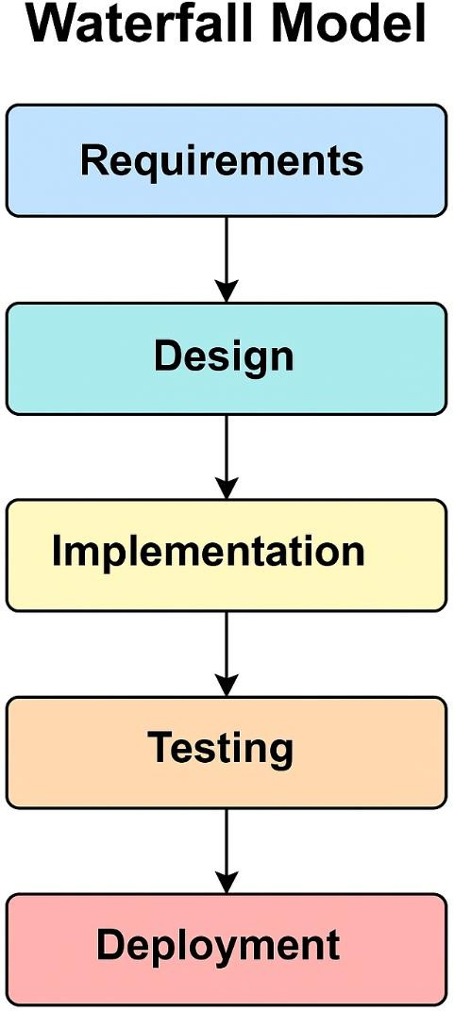

Figure 1: Waterfall Model Design for Automated Defect Detection Project

Spiral Methodology for Automated Defect Detection
The Spiral Model integrates iterative development with elements of risk assessment and prototyping. For our project, it allows continuous refinement of the defect detection system by enabling repeated cycles of feedback, improvement, and evaluation. It is particularly beneficial for image-based systems requiring tuning and optimization.

Phases and Activities of the Spiral Model
- Determine Objectives Define specific system targets such as defect types (cracks, leaks), accuracy goals, and user needs.
- Identify and Resolve Risks Evaluate model accuracy, dataset
availability, and system limitations. Adjust design accordingly.
- Develop and Verify Build the defect detection modules using image samples, test preprocessing and YOLO integration.
- Evaluate and Plan Next Iteration Analyze testing outcomes and supervisor feedback, and prepare for enhancements in the next cycle.

Advantages and Disadvantages of the Spiral Model

Advantages
  - Excellent for handling complex or high-risk projects.
  - Allows continuous prototyping and refinement.
  - Supports early detection of risks and errors.

Disadvantages
  - Requires expert risk analysis skills.
  - Can become expensive and time-consuming.
  - Not suitable for small-scale, quick projects.

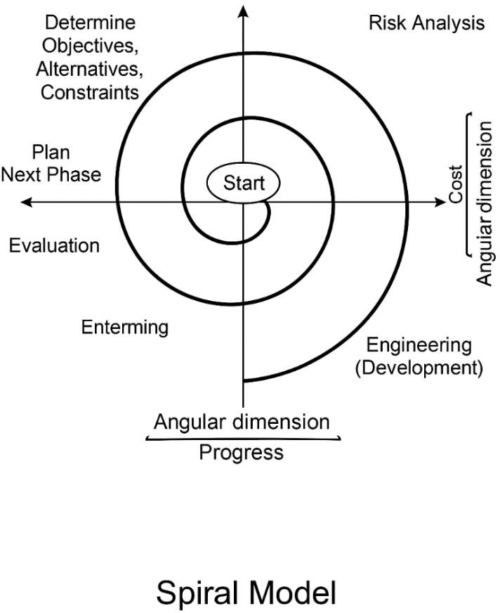

Figure 2: Spiral Model Design for Automated Defect Detection Project

VU Process Model (Hybrid Approach)
The VU Process Model is a hybrid of the Waterfall and Spiral models. It enables structured progression of software phases while incorporating iterative loops for supervisor feedback, risk assessment, and prototyping. This model is ideal for academic projects where review and correction cycles are critical to successful completion.
Phases of the VU Process Model

- Gathering and Analyzing Requirements
- Planning
- Analysis and Design
- Development
- Final Report and Viva
Each phase includes feedback elements such as supervisor reviews, prototyping sessions, and risk evaluation to ensure the project evolves effectively.
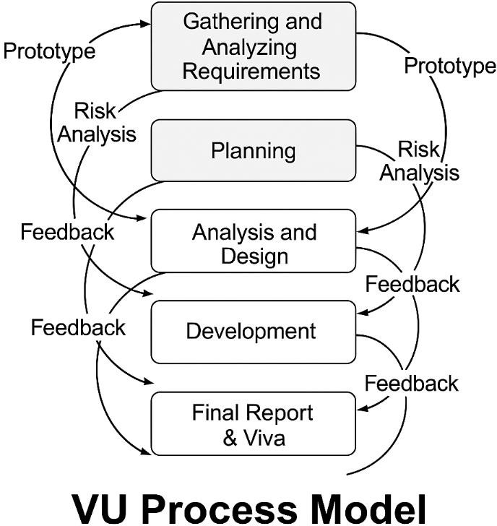

Figure 3: VU Process Model Diagram for Automated Defect Detection Project

Work Plan

The Gantt chart for this project "Automated Defect Detection Using Image Processing," presents a detailed timeline of the project's key phases and activities. It breaks the entire development process into manageable tasks, starting from requirement gathering and extending through planning, analysis, development, testing, documentation, and final presentation preparation.
Each task has been scheduled with realistic start and end dates based on academic deadlines provided by the university. The Gantt chart ensures that each phase flows logically into the next while maintaining clear time boundaries for focused progress. It also helps in identifying dependencies between tasks and avoiding any overlapping or scheduling conflicts.
5/2/20256/21/20258/10/20259/29/2025

Requirement gathering

Planning

Analysis and Design

Development

Testing & Debugging

Final Report Preparation

Viva/Presentation Preparation

Figure 4: Gantt chart

CHAPTER 2
Designing the Project

2.1 Introduction
This design document provides the exact technical outline of the project “Image Analysis with Automated Defect Detection.” It bridges the gap between requirement analysis and the implementation stage of the software development lifecycle. This document outlines the system’s structure, behavior, and architecture based on functional and non-functional requirements specified in the SRS (Software Requirements Specification).

2.2 purpose
This design document aims to present an image document that is bordered with every aspect of the system “Image Analysis with Automated Defect Detection” before coding to ease the development process. It describes the operation of the system to the developers, testers, and project managers and gives a common ground for all implementers and evaluators on how the system is expected to operate and be collaborated on.
2.3 scope
This design document outlines the architectural and structural outline for the system “Image Analysis with Automated Defect Detection.” It describes how the system is intended to be built in order to satisfy design requirements in the SRS through modules, components, and interactions. This document acts as a starting point for development, trusts all stakeholders understand how the system is designed to function, interact, and be implemented in different phases.

2.4 definitions, acronyms and abbreviations

2.5 Architectural Representation (Architecture Diagram)

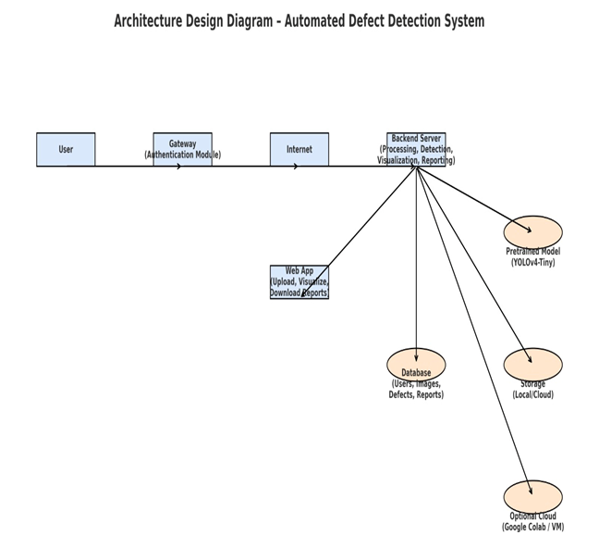

2.6 Dynamic Model: Sequence Diagrams

Generate Report Sequence

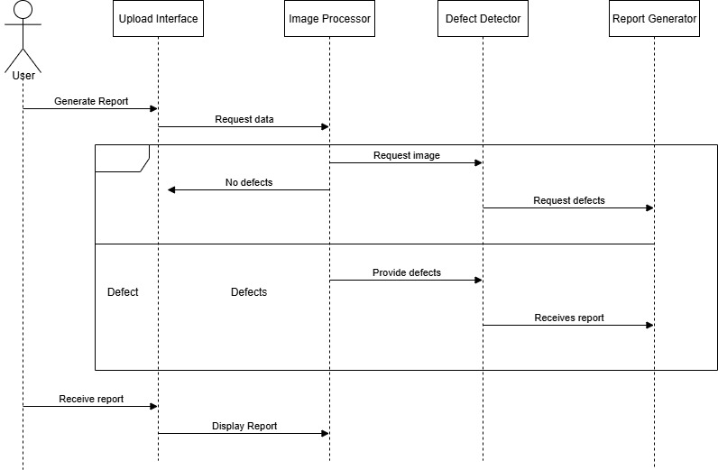

Upload Image Sequence

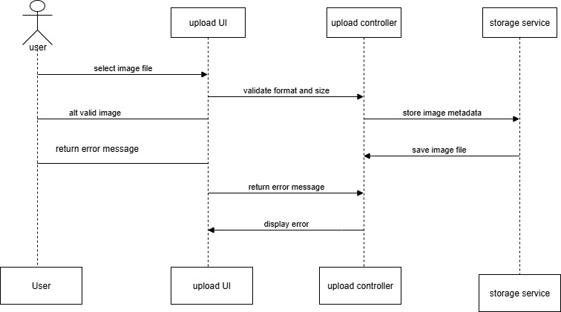

User Registration sequence

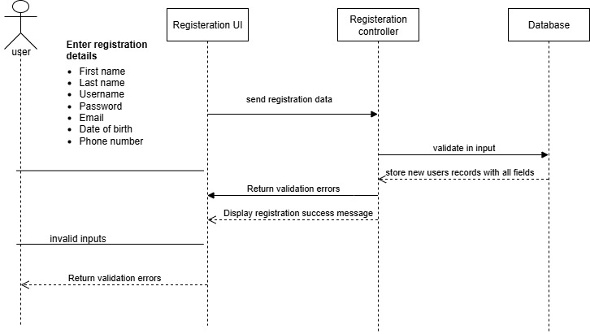

Preprocessing Image Sequence

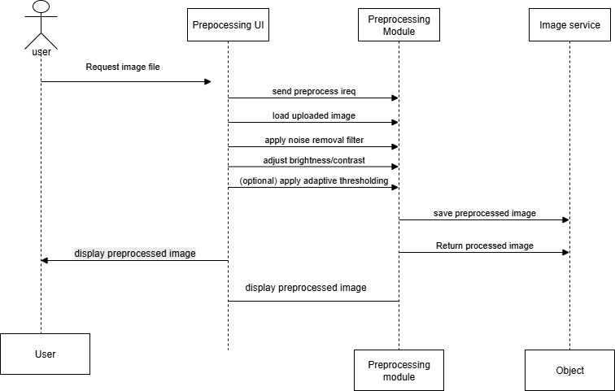

Defect Visualization Sequence

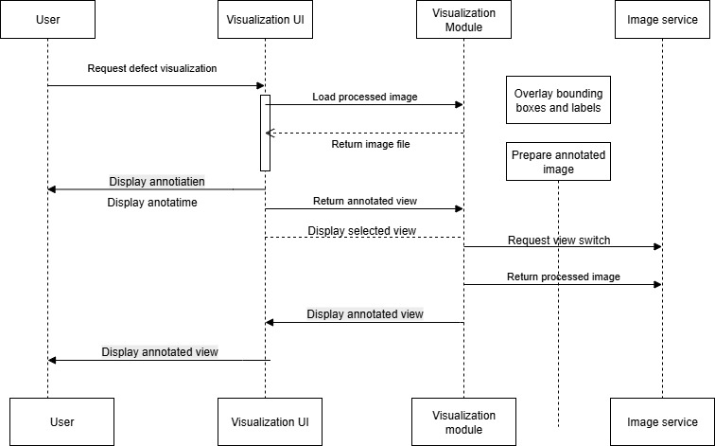

2.7 Object Model/Logical Model: Class Diagram

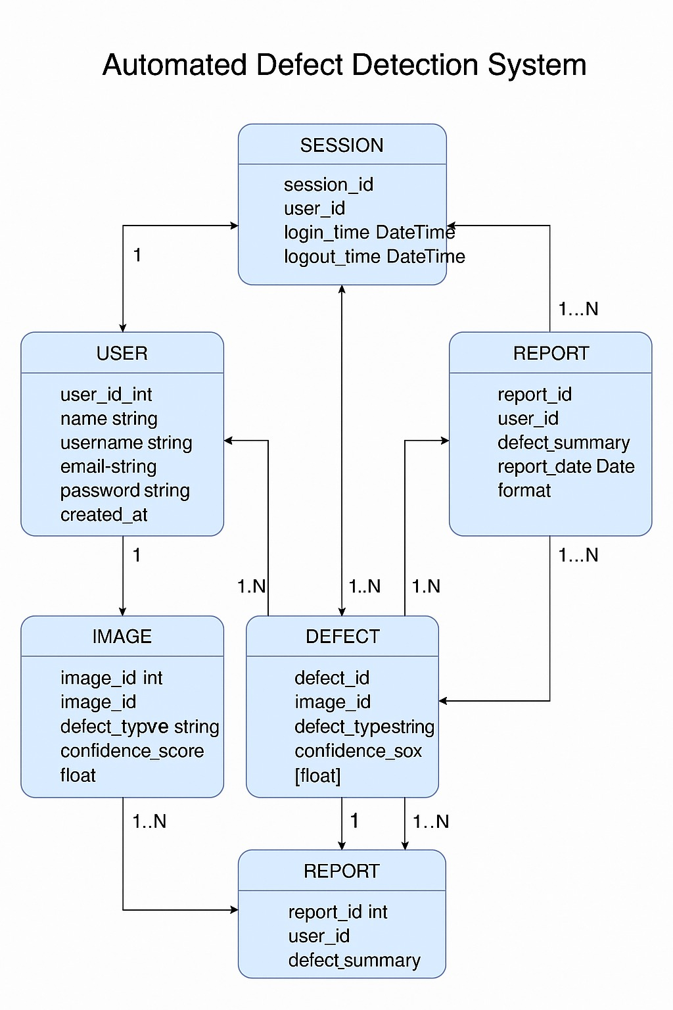

2.8 Database Model (Database Diagram)

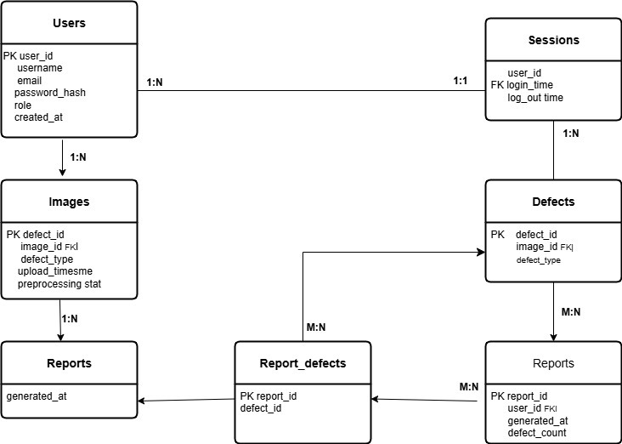

2.9 Graphical User Interfaces

CHAPTER 3
Development

3.1 Development plan (Architecture Diagram)

REFERENCES

APPENDIX

